Anita Pradhan
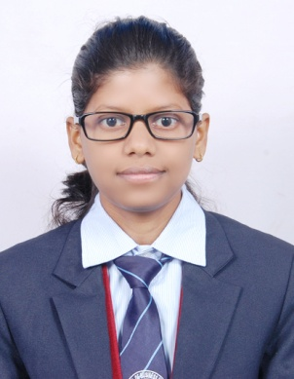
Contact No.: 8088313890
Email ID: anitapradhan976@gmail.com

Career Objective:-
Seeking a challenging and responsible position in HR to utilize my skills and abilities in a firm that offers me a professional growth constantly which will help me to dedicate fully and work up to my potential.
Educational Qualifications:-
- MBA (HR) from United School of Business Management And Studies,BBSR (BPUT).
- BBA from United School Of IT And Management Studies,BBSR (UTKAL UNIVERSITY).

Project:-
Summer Internships (MBA)
- Company Name - OPTCL
- Place -Bhubaneswar
- Duration -45days
- Project Topic -Training & development

Personal Skill:-
- Have good presentation skill
- Leadership skills
- Team building
- Adaptable
- Willingness to learn new things
- Creative thinking
- Potential worker ,
Achievements/Certifications:
- Awarded for debate, business quiz, and ad-mad show.
- Attended and awarded Women Entrepreneurship Development Programme 2015.

Hobbies:-
- Listening to Music

Personal details:-

Father’s Name: - Jayakrishna Pradhan
Marital Status: - Single
Gender: - Female
Date of Birth: - 4th June 1988.
Languages Known: - English, Oriya & Hindi.
Nationality: - Indian.

Permanent Address: -
Anita Pradhan.
At/P.O.:Jagannath Colony
Dist:Angul, State:Orissa,
Pin:759116 .
Declaration:
I hereby declare that all the information furnished above is true to the best of my knowledge.

Place: Bangalore
Date: Anita Pradhan

